APPROVED BY
NDAL CONSTITUTIONAL ASSEMBLY MEETING
DECISION No.2 of 06.12.2022, Minutes No. 2022/2

NATIONAL DEFENSE ACADEMY OF LATVIA
DEVELOPMENT STRATEGY
FOR 2023- 2032

Contents

Introduction
- Framework and Context of the NDAL Development Strategy
- NDAL mission and vision
- NDAL values and guiding principles
- NDAL development directions and objectives
- NDAL objectives and implementation indicators
- NDAL infrastructure and study resources
- NDAL performance indicators
- NDAL performance management
- Analysis of the implementation of the NDAL development strategy (SWOT)
- Approval, review and implementation of the NDAL development strategy

Introduction

The Development Strategy of the National Defense Academy of Latvia (NDAL) is based on the National Defense Concept (NDC), which defines the strategic objectives, basic principles, priorities and measures of the national military defense in times of peace, national threat and war.

The NDAL Development Strategy has been developed to ensure the development of priority military capabilities identified in the National Armed Forces (NAF) development plans and, thus, to facilitate the fulfilment of tasks identified in the State Defense Operational Plan (SDPO), the NAF Mobilisation Plan and other NAF plans and legislation.

The NDAL Development Strategy fulfils the objectives and tasks set out in the NAF Personnel Development Policy documents, as well as adheres to the military education guidelines within NATO and the EU. The development strategy of the National Defense Academy of Latvia complies with the requirements of the National Armed Forces Law, Military Service Law, Law on Higher Education Institutions, Law on Scientific Activities, Cabinet of Ministers Regulation No.744 of 16.12.2014 "Regulations on the Activities of the National Defense Academy of Latvia".

The NDAL Development Strategy for 2023-2032 supports the concept "Latvian Higher Education and University Development Concept 2021-2030" developed by the Latvian Council of the Higher Education in 2021 and is designed as the highest planning document for the development of the NDAL. The internal laws and regulations of the NDAL will be developed and updated in line with the goals and objectives set out in the NDAL development strategy.

- Framework and Context of the NDAL Development Strategy

The State Defense Concept, approved by the Saeima on 24 September 2020, states that the aim of national defense is to prevent and overcome possible threats to the state, to guarantee statehood, the capacity and continuity of the state power and system, the preservation of the nation, and to promote a responsible attitude towards the state and its security among all Latvian citizens. It stipulates that state protection applies to every Latvian citizen, and therefore guaranteeing state protection is not only the duty of state authorities and administrative institutions, but also the responsibility of every individual.

The psychological resilience, will and readiness of a society and of each individual to defend their country must be built in peacetime to succeed in times of national threat and war. Comprehensive national defense is the best tool for building resilient societies and efficient economies to meet the challenges of the international security environment.

Russo-Ukrainian War and global trends show that the current balance of power has shifted and that peace and stability cannot be maintained by diplomatic and economic means alone. The national defense system must be able to remain vigilant in order to identify early signs of threats. The public authorities and administrations must take all necessary measures to safeguard the democratic order and ensure the continuity and capacity of public authority.

The National Armed Forces (NAF) are the cornerstone of the country's defense system, and their units must be combat-ready. The NAF must be able to quickly detect, localise and disrupt a covert or overt attack. In the development of the NAF military capabilities, emphasis is placed on the development of early warning, command and control and communications systems, force mobility, high readiness and rapid reaction units and control of the Baltic Sea and air routes to ensure the arrival of NATO-allied military units in Latvia.

The NAF and NATO-allied military units can deter a potential aggressor from attacking, or, if massively resisted, inflict such heavy damage that its will to continue its aggression would be severely undermined. In the event of occupation of national territory, the NAF should employ small unit tactics with decentralised command, where sub-unit commanders are able to take the initiative and act independently within the framework of the higher commander's intent. Moreover, the NAF has a duty to plan and organise the public resistance in good time.

The NAF Development Plan is a strategic-level document based on the Military Threat Analysis, taking into account the guidelines set by the NDC. The development of the Plan is synchronised with NATO defense planning process. The NAF Development Plan is not publicly available and is a classified document.

The NAF Development Plan for 2016-2028 identified the following priority military capabilities to be developed in the medium term: early warning, air surveillance, air defense, mobility and counter-mobility capabilities, ground combat capabilities and hosting nation support. In turn, the NAF Development Plan for 2020-2032, thanks to the increase in the defense budget in the coming years, identifies the following priority military capabilities to be developed in the medium term: air defense, missile artillery, coastal defense and mobility of the NAF units. In 2024, the NAF Development Plan is likely to further refine the priority military capabilities to be developed.

Military capability is a set of qualitative and quantitative characteristics. Depending on the purpose and mission, military capabilities are materialised in the NAF tactical publications and training programmes, the development of units and infrastructure, the selection and training of personnel and leaders, material and technical means (equipment, armament, transport, means of communication, software, etc.), as well as interoperability with the military units of other NATO Member States.

The development of the NAF military capabilities is closely linked to the development of the NDAL, as officers are the backbone of the armed forces. Commanding officers, staff officers and specialist officers, in accordance with their position and competence, directly ensure the combat readiness of the NAF units by planning, organising and controlling the execution of tasks assigned to the NAF units. Officers provide training and preparation for military tasks for both Professional Military Service (PMS) soldiers, National Guard soldiers, reserve soldiers and reservists.

The NDC states that the NAF will see an increase in the number of personnel in the coming years: up to 8,000 PMS soldiers, up to 12,000 National Guard soldiers and up to 6,000 reserve soldiers, which means that more officers will be needed to train and lead them. NAF Joint Headquarters regularly updates the number of cadets to be trained at the NDAL to ensure that NDAL units are manned with junior and mid-level officers.

In order to strengthen national defense and to ensure the capacity of the Latvian state and society to prevent and cope with a national threat or war, a State Defense Service (SDS) will be established in the coming years. Within the SDS, all male Latvian citizens aged 18 to 27 will be able to choose one of three types of service: State Defense Service, the National Guard Service, special military training for university students or national civilian service (as an alternative service) under the supervision of other ministries. This means that the NAF will have to train between 1,000 and 7,500 personnel per year according to the NAF training programmes and standards. Given that the number of NAF trainees will increase significantly in the coming years, it is planned to invest more in the areas of NAF infrastructure, material and technical support and personnel.

The personnel policy of the NAF should create the necessary preconditions for attracting and retaining sufficient, qualified and motivated personnel, but demographic problems and changes in the labour market may significantly affect the attraction and motivation of the required personnel. Insufficient numbers of soldiers and specialists pose a serious threat to the functioning of the national defense system and the fulfilment of the tasks assigned to the NAF.

The Law on the National Armed Forces and other legal acts stipulate that the NAF shall cooperate with state, local government and private institutions in accordance with the procedures established by law. Cooperation is based on civil-military cooperation, which is a planned and coordinated action of state administration institutions, society and the NAF to overcome national threats. In the performance of its tasks, the NAF provides support to the State Police, the State Border Guard, state security institutions, the civil protection system, the Youth Guard and educational institutions (for the implementation of the National Defense Training). This means that the knowledge and skills of officers trained by the NDAL go beyond military education.

Nowadays, an NAF officer must have good knowledge and skills in the following areas, apart from military subjects:
- Principles of Comprehensive National State Defense and their implementation;
- Structure of Latvian public administration and principles of public administration;
- Good practice in public institutions in the areas of project preparation, budgeting and implementation;
- NATO objectives, structure, military capabilities and cooperation among member states, as well as the contribution of the NAF to the collective defense system;
- EU objectives, institutions and cooperation between Member States, as well as Latvia's contribution to security issues;
- The fundamental rights of the population and their protection, as laid down in the Latvian fundamental law and other international laws;
- Management theory, management principles, military psychology and organisational culture;
- Pedagogy, interpersonal skills and the ability to work with people from different organisations and countries;
- Knowledge of one (official NATO language) and one foreign language;
- Information technology, digital skills and cybersecurity;
- Strategic communication and media literacy;
- Artificial intelligence, robotics and biotechnology, etc.

The wide range of tasks and the complex geopolitical situation of the NAF have an impact on the demand for new officers and specialists in various fields, thus challenging and contributing to the development of the NAF.

Latvia faces a strategic environment that is dynamic, global, complex and uncertain. The lines between peace and conflict, political and military, strategic and tactical, kinetic and non-kinetic are blurred. Potential strategic competitors are constantly trying to undermine the political and military strategic goals of Latvia and its allies, deploying increasingly complex strategies, incl. through coordinated political, military, economic and informational efforts. NAF units must be intellectually and technologically advanced to effectively respond to this pervasive threat. Therefore, the NDAL study programmes must have a balanced proportion between exact and strategic subjects, so that officers can evaluate threats and their potential consequences, learn and use modern combat techniques, equipment, data processing and transmission means. Knowledge of academic and specialized literature, development of theoretical and empirical understanding will contribute to the strengthening of cadets' professional competence and readiness to respond to new problems and changing conditions.

Science, research and innovation are an essential part of national security, national defense and the military industry, so the NDAL must create an innovative environment for the defense industry. We are increasingly faced with cyber, hybrid and other asymmetric threats, including disinformation campaigns, and increasingly sophisticated and disruptive technologies. Taking into account the scientific guidelines of NATO and the needs of NAF, NDAL, as a university of applied sciences, must be able to create, select, offer effective solutions, incl. adopt innovative technologies to improve the combat capabilities of the NAF. It is necessary to establish interdisciplinary research links between NDAL scientific centers, within the framework of which the questions "what?", "why?," "in what way?", "when?" will be answered.

International cooperation of the NDAL with the NATO chief scientist office and its institutions under the STO, other NATO and EU universities, centers of excellence and research organizations can ensure the transfer of knowledge and experience to the Latvian defense industry. NDAL must regularly organize conferences, seminars and training courses with the participation and presentation of internationally recognized researchers and experts, incl. NATO STO CSO scientific panels and scientific institutions of other allies. In addition, close connection and cooperation with international level researchers and experts, as well as the publications of the Academy's researchers in international journals, will ensure the quality control of the research conducted at the Academy and the realized study programmes. The involvement of cadets in the academy's projects and research can improve the academy's ranking among other universities and promote the interest of talented young people in studying at the NDAL.

The NDAL was established on 13 February 1992 and its main objective is to train professional officers of the NAF - leaders with high morals, honour and sense of duty, who are able to successfully lead their subordinates and assume responsibility for the performance of tasks, as well as to conduct research in the field of national defense and security. Advanced military education is available at the Baltic Defense College (BALTDEFCOL) in Tartu, which aims to provide training for officers and defense officials of the Baltic Armed Forces in accordance with common NATO standards and methodology, thus facilitating better cooperation of the Baltic Armed Forces with NATO allies. NDAL cooperates with BALTDEFCOL in the implementation of the Master's programme.

The NDAL is the inheritor of the traditions of the Latvian Military School and is the only higher military education institution in Latvia that trains officers for the regular forces of the NAF and the National Guard. During its existence as a higher education institution, NDAL has experienced various changes in the structure of the Academy, its teaching staff and the content of study programmes. The historical changes of the NDAL were determined by the NAF military capability development plans, available financial resources and military education priorities of the period.

In the period 1992-1997, the foundations were laid for military education at the NDAL. The period 1997-2003 in the field of military education is characterised by the pursuit of a multi-level concept of NATO and military education that meets military needs and generally accepted educational standards. The period 2003-2010 is characterised by relative stability in the acquisition of officers' education and cooperation with other Latvian universities in the implementation of bachelor study programmes. Since 2002, NDAL has the right to implement accredited study programmes and to issue state-recognised diplomas of higher education. As a result of the Latvian economic crisis, the education of NDAL officers underwent significant reforms, with the period 2010-2013 being characterised as a period of survival - significant structural changes were made to the NAF and the number of NDAL academic and general staff was reduced. In 2013, the NDAL acquires the right to implement the accredited field of study "Military Defense" and the professional higher education study programmes included in the field of study, awarding relevant degrees and professional qualifications.

Since 2014, with the start of the Russo-Ukrainian War, additional funding has enabled the implementation of a number of projects aimed at building new combat capabilities and sustaining existing ones through effective vocational training and general studies courses, as well as modern teaching methods. Active international cooperation with higher military education institutions in other countries is being initiated to provide cadets, students and faculty with comprehensive theoretical knowledge and exchange of experience.

Currently, the NDAL successfully implements the accredited study programmes, continuously improving the quality of studies in order to meet the standards of higher education in Latvia and to be able to provide NAF officers with the necessary professional competences.

Looking back at the complex periods of the NDAL development and the different types of officer education, it is safe to say that the NDAL has fully embraced the NDAL motto in its development: "Per Aspera Ad Astra (Through Thorns to Stars)", where the entire focus is on achieving excellence in the profession for future Latvian NAF officers.

NDAL stands out among other Latvian higher education institutions not only as the only higher military education institution that prepares officers capable of managing people, processes and learning modern technologies, but also creates strong leaders for both military and civilian environments. Students do not experience routine, as a dynamic and highly practical study process is provided, thus strengthening their ability to apply academic knowledge in everyday life. The daily routine of active military service creates a dynamic campus environment, where care for the fitness, growth and well-being of students is of paramount importance. The social guarantees for cadets, including the soldier's salary from the first day of studies, are a particularly important aspect, but it is the provision of a stable and qualification-appropriate job for any graduate that is the biggest advantage of the NDAL, thus meeting the needs of both students and the NAF.

The importance of these advantages is reflected both in the growing number of students who want to study and as a motivating factor for students, thus increasing the number of graduates. For example, the number of graduates from the newly established Land Forces Military Leadership (LF ML) study programme in 2022 has tripled compared to 2017. The total number of graduates has almost doubled in the last six years, thanks to the continuous improvement of the study programmes.

- NDAL mission and vision
Mission

NDAL is a higher education institution of applied sciences, which, in accordance with the standards of higher education, implements professional bachelor's and master's level higher education programmes within the Military Defense study direction, successfully combining students' academic studies with the training of professional military service soldiers in order to prepare knowledgeable, skilled and professional military leaders for the NAF.
The NDAL trains junior officers of the NAF in the specialisations of Land Forces, Naval Forces and Air Force, as well as provides career and lifelong learning opportunities for NAF officers in accordance with NATO and EU military education standards. The NDAL builds and strengthens the sense of belonging of cadets and junior officers to the cadet and officer community of NATO and EU Member States.

Vision

The NDAL is a modern, dynamic, innovative and internationally renowned institution of professional higher military education, conducting research on international and national security and defense issues.

The NDAL enjoys public recognition and trust. It is open to new knowledge, technology and innovation. It introduces new forms and methods of study and research to ensure the integrity of research and studies, an interdisciplinary and problem-solving approach to the training of NAF officers and the development of NAF combat capabilities.

NDAL respects academic freedom, ensures the continuous improvement of the qualifications of academic and general staff and the quality assurance and development of study programmes. The NDAL strengthens the security capabilities of the Latvian people, develops democratic values and protects the core values of Latvian culture and Latvian identity. The NDAL, as the inheritor of the traditions of the Latvian Military School, preserves and develops the traditions of the Latvian Army and NAF officers.

- NDAL values and guiding principles
The NAF Commander has set the values and standards for NAF soldiers, so that the personnel of the Armed Forces are educated in accordance with these values and standards. The values of NAF soldiers (selflessness, courage, justice, dignity, loyalty and love) define their personality and motives for action. NAF standards (legality, reasonableness and professionalism) on their turn define how a soldier should behave regardless of the place, events and circumstances.
NDAL cadets are soldiers and students at the same time, whose values as soldiers are complemented by those of the Academy. NDAL values guide and develop people as they highlight the most important requirements for cadets during their military education and military profession. The NDAL core values apply equally to the Academy's military and civilian, academic and general staff.
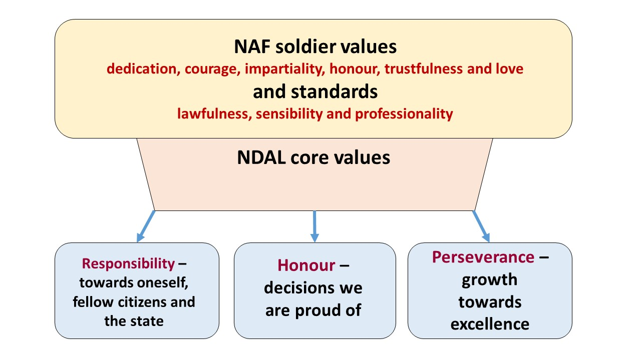
Responsibility towards oneself, fellow citizens and the state encompasses the commitment of members of the military profession to Latvian society and the state, as soldiers are entrusted with the responsibility to develop the military capabilities of the NAF and to perform specialised tasks for the benefit of society and the state. Every soldier is responsible for his or her actions, the outcome and the consequences. The level of responsibility increases with each successive rank and position in the military organisation. Cadets are obliged to study hard and successfully acquire general and military knowledge in order to develop their professional competences. NDAL personnel have a common duty to comply with the NDAL Internal Regulations, to use the resources allocated by the State efficiently and effectively, and to respect the State's inventory, equipment and armament.
It is an honour to think, plan and do only what is legally and morally right to ensure timely, balanced and sound decision-making. Honour and respect are due to every person who faithfully carries out the duties entrusted to him. Honour is the summation of each person's good virtues and the individual's inner willingness to do any task to the best of his or her ability, so that the NDAL staff can be proud of the end result.
Perseverance involves the purposeful and continuous acquisition of new knowledge and skills in order to maintain and improve your professional competence. The student's ability to learn independently and continuously is important for the comprehensive development of the leader's personality and for the soldier's active participation in the processes of state and society life. In order for cadets to overcome the difficulties of the Academy's theoretical courses and practical training, mutual cooperation, teamwork and professional culture, a spirit of healthy competition and a desire for excellence in NDAL studies and in future service in the NAF must be fostered. To provide effective leadership, today's military leader must have extensive knowledge of soldier relations, communication and interaction, military theory and history, tactics, decision-making procedures and technology. In the future, excellence will come from hard-working, creative and critical thinkers who can quickly select and analyse information, learn new technologies and working methods, and solve problems in life-changing situations.
In the NDAL study process, the study content of the Military Leadership study module and professional study courses is directed towards the comprehensive personality development of student soldiers and the development of the personality traits necessary for a military leader and the deepening of the values of the NDAL as a military organisation culture (Soldiers' Ethos):
Patriotism - love of one's country, country, working for it and defending it militarily.
Purposefulness - clearly defined study requirements, orientation towards the professional competences to be delivered.
The duty of cadets is to study hard, while the duty of commanders, course leaders, instructors and lecturers is to provide quality knowledge in order to improve the general theoretical and military-professional competences of students.
Discipline - observance of the NAF legislation, laws, regulations, rules of procedure and the standards of conduct of the NAF internal order.
Respect - fair treatment at all levels of military leadership, adherence to ethical standards.
Leadership - a form of leadership that transforms the value system, standards, goals, needs and ethics of people and the NDAL in line with the development guidelines of the NAF.
Cooperation - effective communication in the study process at all management levels, especially between students and lecturers.
Continuing professional development - the NDAL ensures continuing professional development of officers and lecturers.
Research ethics - to ensure the objectivity of your research, and to communicate the results of your research to the public.
Self-development - professional development.
Excellence - maintaining the combat skills of professional soldiers.
The NDAL complies with the laws and regulations of Latvia in its activities, acting in accordance with their meaning and purpose. The NDAL follows the principle of good (proper) governance in the university, balancing the requirements of the military organisation, the needs of the independent staff and the needs of the students for development. To ensure the quality of the Academy's activities, the following key principles must be respected:
- The management of the NDAL must be open, honest and competent in protecting the interests of the Latvian state and society;
- The leadership of the NDAL must be focused, persistent and honest in matters of national defense policy and the fulfilment of the objectives and tasks set by the NAF;
- The management of the NDAL must ensure that decisions are taken in a timely, considered and reasoned manner and that the decisions taken are followed up;
- The NDAL leadership fosters a fair, honest and open environment at the Academy to promote NDAL staff participation, performance and understanding of values and outcomes;
- The institutional set-up of the NDAL needs to be improved in order to ensure an efficient, coherent and democratic functioning of the Academy in scientific, study and administrative matters;
- NDAL staff promote continuity of professional and academic knowledge and are flexible in adapting to new challenges and solutions;
- NDAL staff shall ensure openness, data protection, correct and fair procedures within a reasonable time to respect and reconcile the legitimate interests of the State, society and individuals;
- The NDAL staff shall ensure the prudent, sound and thrifty management of public property, allocated funds and resources.

The performance of the NDAL should be assessed in terms of economy (investing less), efficiency (investing according to benefits) and effectiveness (investing wisely). In the future, the intellectual capacity and financial resources of the Academy's staff should be concentrated on priority tasks and projects.
Greater individual accountability of the Academy staff for the achievement of specific results, an improved management style based on cooperation and teamwork can improve the development of Academy staff, their involvement in key decisions and their job satisfaction.

- NDAL development directions and objectives
Rationale of the NDAL Strategy
To maintain professional military capabilities and to promote high quality of studies in order to prepare NAF officers as leaders/commanders with strong leadership skills, high motivation and professional competence for military service in NAF and EU/NATO multinational units.
Priority areas for the NDAL development
In the period from 2022 to 2032, the NDAL will focus its activities on five main directions in order to continuously improve the quality of studies and the professional competence of soldiers, as well as to ensure that soldiers receive professional higher education in various study programmes that meet Latvian higher education standards and fit into the EU and NATO military education system.
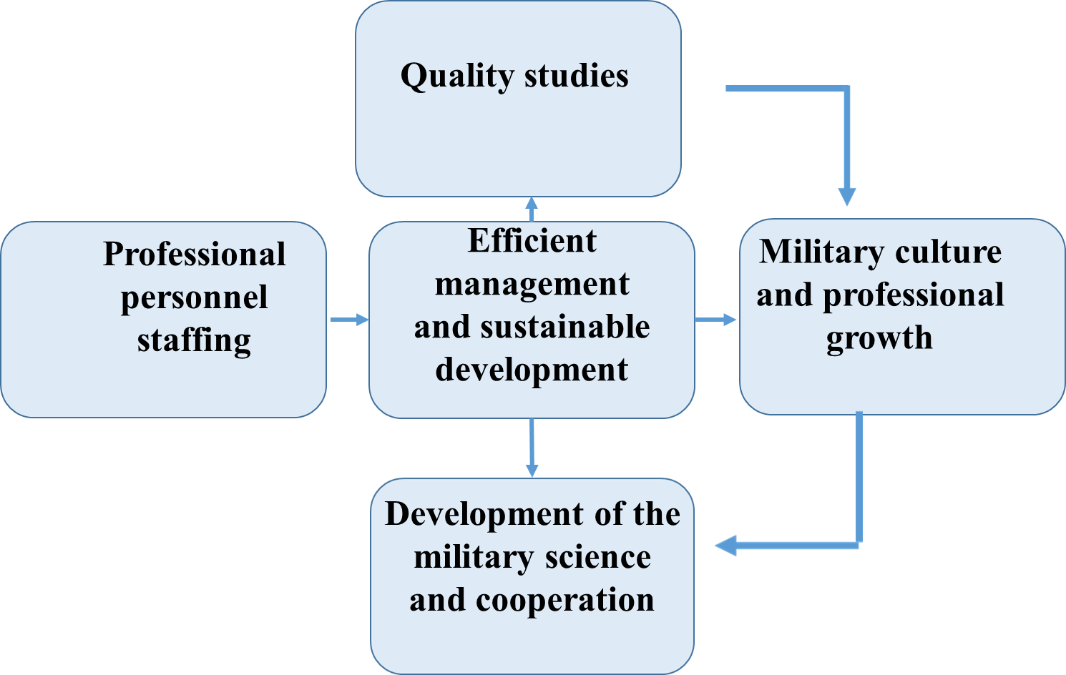
Priority objectives are set in line with the NDAL development directions.
Directions for development | Strategic objectives
Effective governance and sustainable development | - Effective governance - to balance the NDAL command leadership as a NAF unit in the performance of military tasks with the NDAL decision-making bodies in academic matters as stipulated by the Law on Higher Education Institutions.  - Sustainable development - efficient planning of financial and administrative activities, improvement of the NDAL infrastructure to ensure a modern study environment.  - Recruitment and selection - improve recruitment opportunities and selection procedures for study at the NDAL in line with the NAF personnel growth plan.  - Combat Capability Maintenance - synchronise NDAL studies with the maintenance of soldiers' professional combat capability in accordance with the National Defense Plan.
Professional staffing | - Staffing - to staff the NDAL, ensuring high professional competence of military and academic staff.
Quality studies | - Quality studies - on the basis of the NAF development plan for priority military capabilities to be developed in the medium term, to ensure quality studies in accordance with the professional specialisation of regular forces units and academic education standards.  - Internal and external quality monitoring - NDAL is responsible for the internal quality system that meets the external quality requirements of the employer and higher education standards.
Scientific development and cooperation | - Development of security and defense research and military science - to conduct academic and applied research in the field of security and defense and to progressively increase the number of publications and citations of NDAL academic staff in academic journals included in the SCOPUS and Web of Science databases.  - International cooperation - to ensure the integration of the NDAL into NATO, the EU international military education space, by improving student and academic staff mobility programmes, as well as to promote international cooperation of the NDAL in maintaining professional military capabilities.
Military culture and professional development | - Military culture - to develop the professional values of soldiers, to maintain military traditions and symbols, to create a positive image of the NAF in society.  - Leadership and Soldier Ethos - to nurture and prepare NDAL students as professional service soldiers, future commanders, who possess high general physical fitness, mental resilience and leadership qualities to be able to perform the tasks assigned to them under any circumstances.  - Professional development - lifelong learning, career and skills development courses.

All schools and professional competence centres under the command of the NAF Training and Doctrine Command cooperate to ensure effective and sustainable development and professional growth, both in the implementation of accredited study programmes and in the implementation of lifelong learning, career and skills development courses:

TRADOC Commander / NDAL Rector

TRADOC HEADQUARTERS

Language School
National Defense Academy of Latvia
Signal School

Combat Support and Supply Centre
Latvian Naval Training Centre
Infantry School
NCO School

Non-Commissioned Officer’s (NCO) School provides instructors and university students of the National Defense Forces with the opportunity to acquire professional qualifications necessary for military service, as well as general knowledge and skills in accordance with the standards set by the Ministry of Defense and the NAF.
The Infantry School implements adult non-formal education programmes and qualification courses for individual training of soldiers (basic military training course, soldier specialist course and reservist military training course, extended first aid training).
The Naval Training Centre organises individual training - mine detection, mine clearance; diver training.
The Combat Support and Supply Centre conducts adult education programmes and individual training in areas such as explosive ordnance disposal; anti-tank weapons and armoured vehicles training; indirect fire support and military engineering.
The mission of the Signal School is to provide the NDAL with uniform, high quality and NATO-compliant training of specialists at various levels in communications specialities, computer hardware, computer software and cryptography.
The Language School is responsible for foreign language training to prepare NAF personnel for work in NATO structures and NAF units, training in foreign military educational institutions, implementation of international cooperation projects and participation in international missions.

- NDAL objectives and implementation indicators
Based on the five directions and strategic objectives for the development of the NDAL, the following priority tasks and indicators for the implementation of the development strategy are identified for the NDAL for the period 2022-2032:
  - Effective governance and sustainable development
Strategic objective | Tasks | Implementation indicators
Effective governance | NDAL implements accredited study programmes within the study field "Military Defense", ensuring the educational needs of soldiers in accordance with the career system of the NAF.  -----------------------------------  Ensure the functioning of the NDAL decision-making bodies in accordance with the Law on Higher Education Institutions.  --------------------------------------  NDAL to balance MoD/NAF military education requirements with the Latvian higher education standards.  ---------------------------------------  Make changes to the structure and funding of the NDAL as necessary and appropriate to the needs of military education.  ---------------------------------------  The Student Council ensures the active involvement of cadets in the management of the study process and the improvement of the quality of studies.  --------------------------------------  NDAL students are trained as professional soldiers. | - The study programmes accredited by the NDAL comply with the National Standard for Professional Higher Education.  - By 2028, a first level higher education study programme for the NAF non-commissioned officers will be developed, licensed and launched.  - By 2024, changes to the Military Service Law (MSL) on the educational requirements for senior officers of the NAF regarding the need for a Master's degree are being introduced, which would result in changes to the systematic nature of higher military education and the implementation of the NAF Professional Master's degree programme "Military Management and Security" by 2028.  -----------------------------------------------------  - The MoD establishes and ensures the functioning of the Academy Council in accordance with the Law on Higher Education Institutions, which is responsible for the implementation of the NDAL Development Strategy and Quality Policy.  - The NDAL ensures the functioning of the collegial decision-making bodies within the framework of the applied higher education institution, as defined by the Cabinet of Ministers and the Law on Higher Education Institutions - Senate, Academic Arbitration Court, Student Council, Scientific Council, Council of Studies, etc., which deal with scientific and academic issues, insofar as they do not contradict the guidelines for the development of the NDAL.  -----------------------------------------------------  - The curricula and content are reviewed annually, following the guidelines and procedures of the NDAL Development Strategy and the NDAL Quality Policy.  -----------------------------------------------------  - The NAF shall implement changes to the structure of the NDAL based on proposals from the NDAL.  - In line with the increase in the number of students at the NDAL, the increase in academic staff posts is planned in a timely manner.  - The functions of the administrative staff of the NDAL are regularly reviewed within the Management Group, ensuring a fair balance between workload, efficiency and remuneration in relation to the workload of the civilian academic and military staff.  ---------------------------------------------------  - The Student Council conducts surveys of cadets and makes proposals to the Rector on improving the quality of studies.  - The Council of Elders is responsible for ensuring that the financial resources allocated are used effectively for the needs of the students.  ----------------------------------------------------  - In the event of a military emergency or war, studies are interrupted and the NDAL takes up combat duties.
Sustainable development | To plan the development of the NDAL infrastructure in order to provide an attractive and modern study environment for students.  ---------------------------------------  Carry out financial and infrastructure development planning in cooperation with the NAF and in accordance with NAF development plans.  --------------------------------------  To provide a practical training area and logistical support for the conduct of combat training. | - The NDAL Welfare Centre is maintained, providing meals for students, a gym and a library.  - The living conditions of students in the dormitories are regularly surveyed to ensure their well-being, as well as the needs of the students in terms of access to the Internet and office equipment, both in the classrooms and in the student dormitories.  - The renovation of the four-storey barracks has been completed, providing additional rooms and modern classrooms.  - Study rooms are continuously monitored to ensure that lecturers and students have the necessary teaching resources.  ----------------------------------------------------  - The NDAL budget plans have been developed and approved at the NAF level, where the NAF leadership recognises the investment in military education as a priority for future development.  -The costs of study programmes are calculated, where in case of unexcused absences, students return the spent funds to the State Treasury in accordance with the requirements of the MOD normative acts.  - NDAL officials shall make timely requests for training resources to the Latvian TRADOC.  ----------------------------------------------------  - To ensure the availability of NAF military training ranges and the use of NAF units’ resources for tactical training, combat shooting and internships of NDAL students.  - Agreements on the use of the site with private parties have been concluded in due time and material and technical supplies have been received at the NDAL warehouses in accordance with TO&E.
Recruitment and selection | Recruit and select highly motivated young people to study at the NDAL in accordance with the NAF Staff Development Guidelines.  ---------------------------------------  To promote the prestige of the NDAL and the interest of young people in military education and a career in the NAF. | - The NDAL management provides an independent, permanent, direct and easy opportunity for young people to apply to study at the NDAL.  - The NDAL student selection procedure ensures the recruitment and education of junior officers as defined in the NAF staffing plans, with a student attrition rate of no more than +/- 13% as at foreign military universities.  ------------------------------------------------------  - The NDAL communicates with the public through the Academy's Internet website.  - The NDAL promotes the quality and competitiveness of its studies as a higher military education institution in the Latvian education space through the mass media.  - NDAL staff and students participate in public and thematic lecture events in schools to promote the military profession.
Maintaining combat capability | Maintaining the combat capability of NDAL soldiers.  ---------------------------------------  In the professional higher education programmes for cadet soldier's professional training, the NDAL implements the Combat Endurance Course (CEC), the Field Camp and the Military Leadership Tactics Course.  ---------------------------------------  The NDAL provides physical fitness programmes for students and independent staff. | -Annual medical check-up by NDAL personnel (soldiers).  -NDAL personnel (soldiers) annually take an exam for the NAF physical fitness standards and A1 qualification with a service weapon.  - The ability of the NDAL personnel to respond in accordance with the State Defense Operational Plans shall be tested periodically on the orders of the NDAL Rector or the NAF Commander.  -----------------------------------------------------  - Cadets are able to complete the military requirements of the CEC course at 98% with the option repeat the exam after one year.  - Students are able to pass the physical fitness standards with a grade of Excellent and with Distinction and to reach at least 60%.  ------------------------------------------------------  -NDAL maintains a staff of highly qualified general fitness professionals and recruits sport coaches in various disciplines for optional classes.  - The NDAL continuously introduces new physical training measures according to the physical fitness results of new recruits and students in order to achieve good and excellent results.

Actualising the status of the NDAL as an applied higher education institution and the only higher military education institution in Latvia, effective management and sustainable development are based on the priority objectives of the National Defense, which determine the specifics of the implementation of the study direction "Military Defense". However, it should be noted that the NDAL system of higher military education is fully aligned with the requirements of NATO and EU armed forces in the field of military education, which justifies the exceptions of the Latvian Higher Education Law for the NDAL activities as an applied higher education institution in Latvia.

Basic principles of the NDAL military leadership

NDAL academic and military personnel policy is determined by the Cabinet of Ministers regulations and laws, with exceptions in the Law on Higher Education
NDAL students are members of the professional military service and perform the duties of a soldier in a military emergency or war situation

NDAL implements professional higher education study programmes in accordance with the LV education standards and the NAF development guidelines
NDAL as a higher education institution is a unit of the NAF

  - Professional staffing
Strategic objective | Tasks | Implementation indicators
Staffing | To recruit NDAL staff on the basis of the Law on Higher Education Institutions, Cabinet of Ministers Regulation No 744 of 16.12.2014, the Law on Military Service, as well as internal normative acts of the NDAL.  --------------------------------------  Maintain a development- and excellence-oriented personnel policy, with highly qualified military, scientific and academic personnel involved in the implementation of military education. | - NDAL has at least five members of academic staff with doctoral degrees.  - Annual performance reviews of independent academic and military staff are performed.  ------------------------------------------  - Performance evaluation of the NDAL visiting teaching staff is carried out.  - Development of an individual work plan by the head of a unit to improve performance or a decision by the Latvian TRADOC commander to terminate the employment relationship.  - In accordance with the NDAL Quality Policy, periodic evaluation of the teaching performance of military guest lecturers is carried out.

  - Quality studies
Strategic objective | Tasks | Implementation indicators
Quality studies | To implement the compliance of the content of the study programmes of Professional Higher Education with the Standards of Higher Professional Education, the Standard of Profession and the Guidelines for the Development of Priority Military Capabilities of the NAF.  --------------------------------------  NDAL students carry out research in security, defense and military science.  -------------------------------------  The content of individual courses is assessed according to the need for military competences in relation to the professional specialisations of the LF, AF and NF.  --------------------------------------  Maintain digitisation and provide a modern learning environment in the e-system.  --------------------------------------  To attract highly qualified military and civilian lecturers to teach general education courses, who will implement modern and interactive study methods.  --------------------------------------  Standardize the Sectoral Qualifications Framework for the Military Officer ( SQF -MILOF) competency module for EU military education.  --------------------------------------  Ensure systematic military education in the composition of non-commissioned officers staff.  --------------------------------------  To update the content of the professional master's study programme "Military Management and Security".  --------------------------------------  Students are generally satisfied with the study process at the NDAL. | - The NDAL complies with the Quality Policy objective by implementing a comprehensive quality management system at the NDAL for the implementation of the study programmes of the accredited study field "Military Defense", as well as for the implementation of military professional career/qualification courses and lifelong learning, which is to be observed by the NDAL management team, academic staff and professional servicemen responsible for the implementation of the NDAL professional higher education study programmes and military training.  - The NDAL has a Training Planning and Support Department (TPSD) and a Methodology Support Unit (MSU), which monitors and is responsible for the compliance of study programmes with the accreditation rules. The NDAL Council of Studies (CS) evaluates and approves changes to study plans.  ------------------------------------------  -NDAL provides the necessary qualifications of lecturers to conduct scientific research.  - Students are able to defend qualification, bachelor's and master's theses with a mark of good to excellent 70%.  -------------------------------------------  - Heads of departments, study programme directors and heads of branches or lecturers submit proposals to the NDAL CS in accordance with the NDAL Quality Policy.  -------------------------------------------  -NDAL hosts the ILIAS e-learning environment platform.  - LAIS is creating a database of NDAL students.  -------------------------------------------  - Responsible-NDAL Military Management Studies Department staff.  - The needs of NDAL staff and students are identified through the organisation of additional courses and seminars.  -------------------------------------------  - By 2032, introduced in the study process, especially in Erasmus modules.  -------------------------------------------  -Licensed first-level professional higher study programme for NAF non-commissioned officers.  -------------------------------------------  - MSL amendments to officer education and career requirements have been introduced.  -------------------------------------------  - Regular NDAL general meetings are organised to provide feedback.
Monitoring the quality of internal and external studies | To ensure an effective Quality Policy of the NDAL, which includes quality control mechanisms for the planning, administration, study content and intermediate and final student outcomes, based on feedback from students, management and lecturers.  --------------------------------------  NDAL cooperates with the units of the NAF Regular Forces - the direct employer in the implementation of study programmes, ensuring continuous external quality control of studies. | - The NDAL has Quality Policy Guidelines approved by the Senate.  - Internal quality monitoring of studies is carried out by programme directors, methodologists and issues are reviewed by the CS according to the periods set by the NDAL Quality Policy.  - The LAIS platform will be used to implement the student surveys.  - Changes to study programmes are justified and implemented in accordance with the study process quality reports.  -------------------------------------------  - Regular surveys of graduates and employers (NAF units) are carried out. The proportion of students who are satisfied with the quality of their studies must be at least 60%.  - The NDAL Management Group is open to rational proposals for improving the quality of studies, taking into account military needs and university requirements.

  - Military science development and cooperation
Strategic objective | Tasks | Implementation indicators
Promoting security and defense research and the development of military science | Promotion of research excellence and international scientific cooperation and visibility of the NDAL, building on the activities of the Defense Technology and Innovation Centre (DTIC) and the Security and Strategic Research Center (SSRC).  --------------------------------------  Conducting research on international and national security and defense issues in line with the needs of the MOD and the NAF.  -------------------------------------  Promote the involvement of cadets in research. | -Increase the total number of publications in SCOPUS and Web of Science databases by 10% by 2025 and by 20% by 2028.  - Increase citation rates of publications in SCOPUS by 10% by 2025 and by 20% by 2028.  - NDAL elected academic staff's overall Google Scholar Hirsch Index increases by 10% by 2025 and by 20% by 2028.  - Increase in co-publications with scientists from other Latvian and foreign universities by 10% by 2025 and 20% by 2028.  --------------------------------------------------  - Some of the studies will be classified, where a report of the results of the studies is submitted to the MoD or the NAF.  --------------------------------------------------  - NDAL students carry out research in security, defense and military science, including interdisciplinary fields of science, under the supervision of qualified lecturers, relevant to the development and defense of diploma thesis, bachelor's and master's theses.
International cooperation | The NDAL maintains and develops international cooperation in the fields of academic education, military professional education and military training, ensuring the overall integration of the NDAL into the EU and NATO military education area in accordance with higher education standards.  --------------------------------------  Increase international scientific cooperation and mobility of academic staff on military expertise. | -ERASMUS+ project implementation, in cooperation with other military higher education institutions, both sending and hosting short- and long-term exchange mobility students and lecturers.  -At least three training modules in the framework of military training under ERASMUS+.  -By 2032, ensure that each student participates in at least one foreign exchange trip or experience exchange in Latvia with foreign military students during the study period.  ------------------------------------------------  - To develop the competence base of the NDAL academic staff in research and lecturing in order to offer guest lectures at foreign military universities.  - To offer advice to students from foreign military universities in the development of research theses.

  - Military culture and professional development
Strategic objective | Tasks | Implementation indicators
Military culture | The NDAL promotes military culture in order to create a link between the society and the NDAL, as well as to promote the prestige of the officer's profession in public opinion by attracting young people to professional service and studies at the NDAL.  --------------------------------------  To uphold the NDAL tradition of honouring history and explore the battle sites where Latvia gained its independence.  ------------------------------------  The NDAL complies with the internal rules of procedure, which are in line with the requirements of the MSL.  --------------------------------------  Ensuring the preservation of national identity and culture.  --------------------------------------  Maintain cooperation links with the public, institutions, as well as Latvian universities and foreign military universities.  -------------------------------------  Ensure academic integrity and ethical principles in the study and research process.  --------------------------------------  Ensuring respect for military ethics. | - Direct selection of candidates for studies at the NDAL.  - Cadets take part in school events promoting the importance of the military profession.  - NDAL cadets represent the values of the military organisation at the partner universities.  - NDAL staff shall conduct themselves in a conscientious manner in public, in accordance with the requirements of the MSL and the Regulations of the Latvian Army.  - Effective communication of NDAL achievements to the media.  --------------------------------------------------  -Military tours and lectures on the history of Latvian military art are organised as a part of the study programmes.  - Heads and sergeants of branches are responsible for ensuring that NDAL students are aware of the military traditions.  --------------------------------------------------  - In addition, the NDAL establishes internal rules of procedure, which regulate the responsibilities and duties of students and lecturers in the study process.  --------------------------------------------------  -During the studies, the cadets are provided with enhanced knowledge of international security, the geopolitical situation of Latvia and the characteristics of national culture, which mark the fighting strength of the Latvian identity in preserving the independence of the State.  --------------------------------------------------  - The NDAL is an open applied university, able to provide professional experts for appropriate participation and lectures on national defense issues at other universities and schools.  - To disseminate scientific research to the public as far as possible.  --------------------------------------------------  -NDAL academic and scientific activities comply with the laws and regulations.  -NDAL has a procedure for checking the originality of students' work and an arbitration board.  --------------------------------------------------  In cooperation with the NAF Chaplaincy Service, the NDAL Code of Ethics has been developed.
Leadership and the soldier ethos | The NDAL commanding staff and lecturers promote students' intellectual, physical and moral development in order to prepare junior NDAL officers as professional service soldiers and mid-level commanders possessing leadership competences.  -------------------------------------  In accordance with the MSL, the NDAL heads and sergeants of branches are responsible for the education of cadets.  --------------------------------------  Provide psychological and spiritual support to soldiers. | - All study programmes share a common model of military leadership, which provides students with theoretical knowledge of military leadership for practical application in military exercises.  - Communication links are ensured at all levels of management regarding the leadership potential of cadets.  - Course supervisors conduct individual discussions and regular educational activities.  - Students are evaluated on their progress and the NDAL Regulations on the Cadet Rating System have been approved by the NDAL Senate and are implemented.  --------------------------------------------------  -In addition to the heads and sergeants of branches, the Chaplain shall conduct the spiritual formation of the students.  --------------------------------------------------  -Students have access to free help from the NAF Psychological Service.
Professional development | Maintain the high level of qualification and specialisation of the NDAL civilian staff and soldiers.  --------------------------------------  Increase the availability and accessibility of lifelong learning, career courses, retraining and skills development programmes. | -Educational needs for staff competences are identified and educational courses are offered.  --------------------------------------------------  -Career and further training for soldiers is provided within the framework of both the NDAL and NATO military education.

- NDAL infrastructure and study resources

The infrastructure of the NDAL (educational, administrative and security buildings and facilities) is located in Riga, Ezermalas Street 8B, in the same area as the NAF Military Police and the NAF Medical Center. The headquarters of the Training and Doctrine Command, the NAF Signal School and the NAF Language School are also located in the same building as the NDAL. The territory of the NDAL is guarded by soldiers of the National Guard units, following military procedures and providing a pass regime for personnel, visitors and vehicles. The Building 1 of the NDAL is guarded by the 24-hour assignment of the TRADOC military personnel and cadets.

The State Police College (SPC) and other units of the Ministry of Internal Affairs (MIA) are located in the same area, but staff and visitors of the Ministry of Internal Affairs use another control pass point with their own pass regime. The NDAL cooperates with the SPC and uses the stadium and the "green zone" under the supervision of the MIA as needed.

Also in the territory is located the Regional Administration Station of the Management Department of the State Defense Military Facilities and Procurement Centre, the employees of which are obliged to ensure the implementation of infrastructure management and development measures by the Ministry of Defense.

All classrooms (20 to 40 seats) in the NDAL Building 1 are equipped with computers, projectors, screens, audio equipment and whiteboards to enable lecturers to use a variety of teaching methods. The NDAL Great Hall (262 seats), Plenary Hall (60 seats) hosts graduation ceremonies and other formal events. The first and second floor classrooms are connected to a single information network, allowing teaching materials and other information to be stored on the NDAL server.

The Academy's kitchen and dining room (50 seats), which can be used for the needs of the Academy and the TRADOC Headquarters, as well as a commercial café (40 seats) are located in Building 1. The same building houses the archives, two document reproduction offices, and several armament and equipment warehouses.
The NDAL has a dormitory on its premises for the accommodation of cadets, which can accommodate 410 cadets and course participants. A second NDAL dormitory building will be completed in 2024 and will be able to accommodate at least 72 cadets and course participants. The building also includes classrooms for 40-60 cadets, training (syndicate) rooms for 10-20 course participants, administrative and recreational facilities. Equipment storage, laundry and drying facilities are provided in both buildings for the maintenance and storage of cadet equipment.
For the professional specialization courses, the NDAL has a Tactical Simulation Centre, a Shooting Simulator (EST 2000) and a 25-metre shooting range, the renovation of which will start in 2023.
Physical fitness is a prerequisite for professional service and the NDAL infrastructure includes several sports fields, a gym and a fitness room, as well as a NATO model obstacle course. Cadets and course participants can use the NDAL parking area for sports and recreational activities.

Cadets use the NDAL library, which is an accredited library of local importance, registered in the Library Register of the Republic of Latvia, for studying general education and professional specialization courses and for research work.

In 2022, the NDAL Welfare Centre was opened, which houses the NDAL library, 24/7 reading rooms, canteen (200 seats), food storage and preparation rooms, an auditorium (300 seats), Student Council rooms, Cadet Club, chapel and a physiotherapy room.

Additional funding will be made available for the renovation of the NDAL infrastructure in the coming years. The renovation of the Security Check Point building, the refurbishment of the NDA large auditorium (120 seats) and the NAF history exhibition space, as well as the improvement of the vehicle parking and equipment storage facilities will be carried out.

Combat skills maintenance and other tactics courses are conducted at NAF ranges (Ādaži Military Training Area, Skrunda Training Area, Lāčusila Training Area, etc.).

The NDAL financial resources come from the national defense budget. The national defense budget is expected to reach 2.2% of GDP in the coming years. The funding allocated to the NDAL is regularly reviewed in line with the priorities of the MoD and the NAF.

In the future, the NDAL should consolidate and streamline its support functions in order to improve the quality and efficiency of staff work and simplify administrative management. As a part of this process, the involvement of the Academy staff in the preparation of proposals to align legislation or processes that contribute to saving resources, increasing efficiency and improving student support should be encouraged.
- NDAL performance indicators
The NDAL implements the Strategy being aware of the changing opportunities and challenges that arise in the process of implementing the Strategy, taking into account the military threat analysis and the guidelines set out in the National Defense Concept. The NDAL's priority criteria for effectiveness as a university and as an NAF unit in peacetime are specified in the NDAL Quality Policy, which reflects the criteria for effectiveness and quality of a military education institution and defines the main evaluation factors:
- Professional service requirements
- Qualifications of human resources;
- Maintaining military culture;
- Learning outcomes;
- Scientific research;
- International cooperation.
In fact, regardless of the specifics of military service, the NDAL has clearly identified two positional states - the requirements of NDAL students and independent staff in peacetime and the opposing requirements in a crisis, threat or war situation.
The main task of the NDAL is to implement higher military education programmes for future officers and to achieve highly professional training so that the NDAL graduates are able to take the lead and defend their country in the event of an immediate military threat, where military leadership competences are a decisive factor.

NDAL cadets must be able to:

- Behave with integrity and be trustworthy;
- Develop intellectual, military and physical competence;
- Foster personal development, leadership skills and the ability to inspire others;
- Think analytically, critically and creatively;
- Communicate and collaborate effectively;
- Make clear and timely decisions;
- Be physically strong and mentally resilient;
- Strive for professional excellence and continuous development.
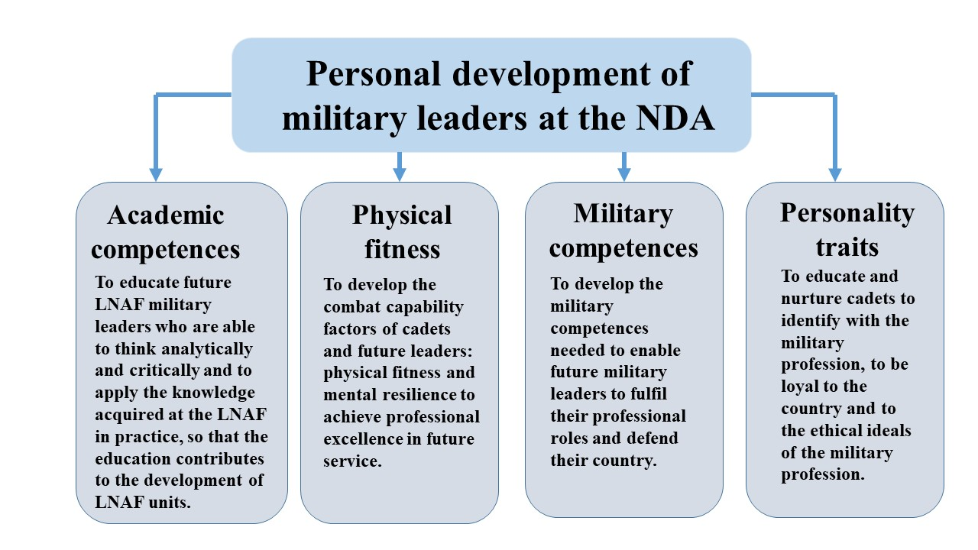

Military competences, the ability to follow and the ability to lead, are developed gradually during academic subjects and practice classes and are described in the Regulations on the Development of Leaders' Capabilities.

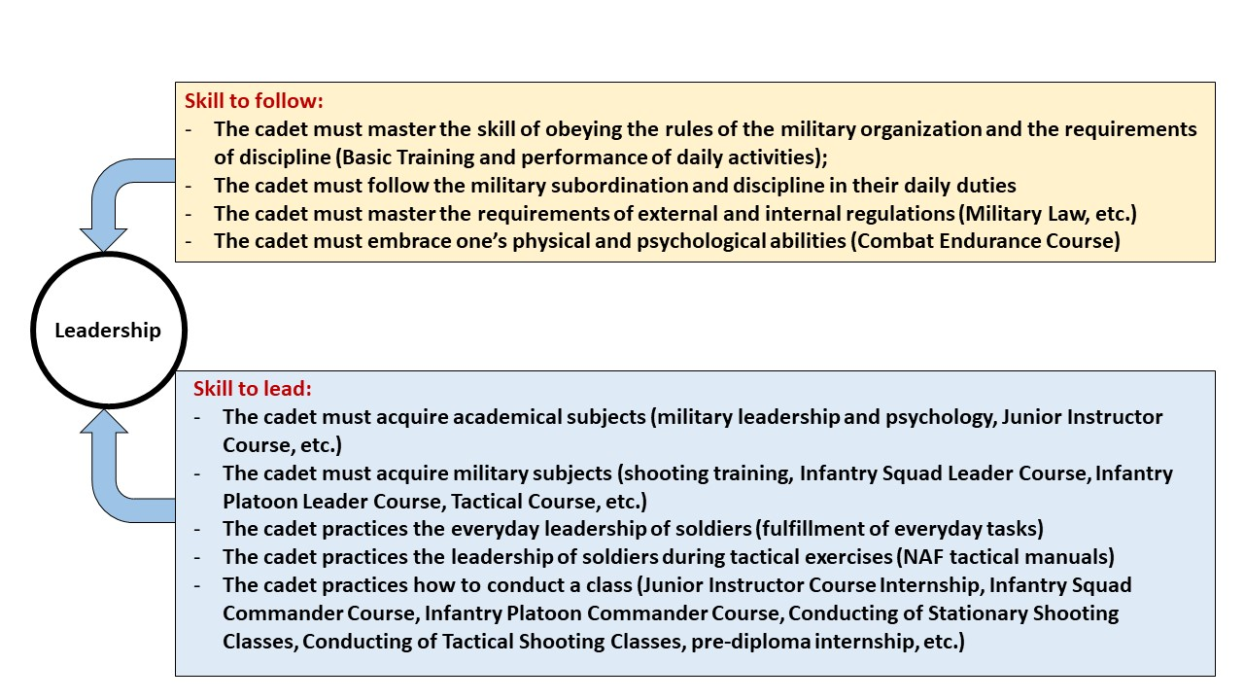
8. Performance management of the NDAL
The activities of the NDAL as an applied university and the management of students' study results are regulated by the development guidelines of the MoD and the NAF, as well as by the internal normative acts of the NDAL. The NDAL performance management is mainly governed by the NDAL Quality Policy, which provides for comprehensive and continuous quality control of studies.
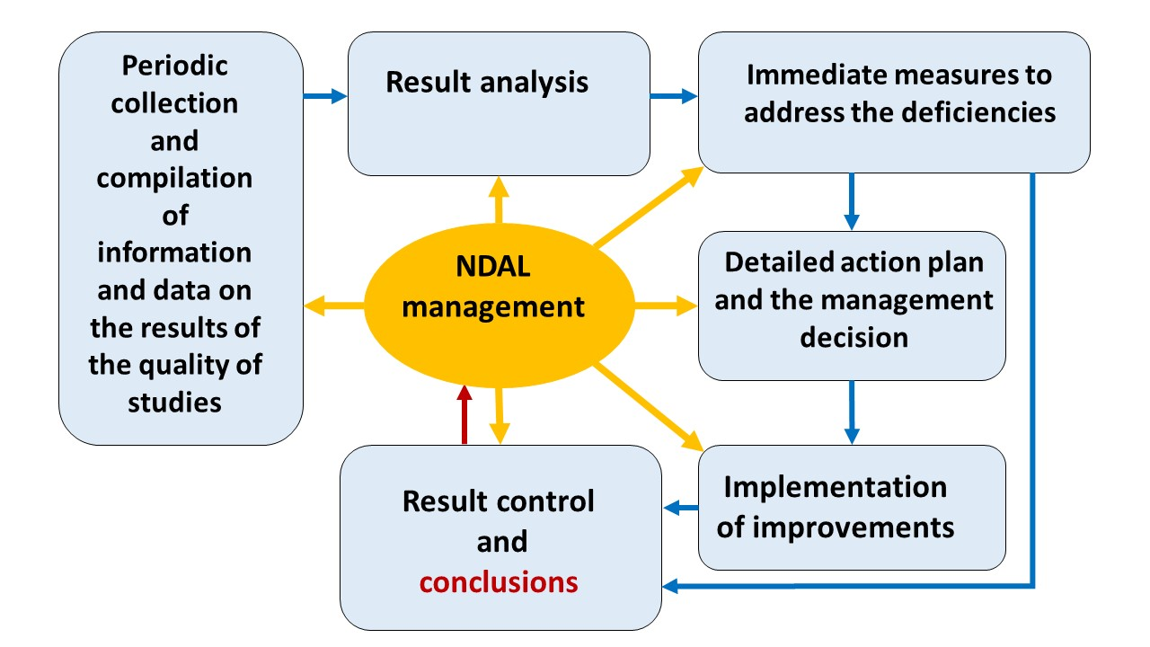
Looking to the future, five key pillars for performance management of the NDAL have been identified, relating to the maintenance of core academic and military values.

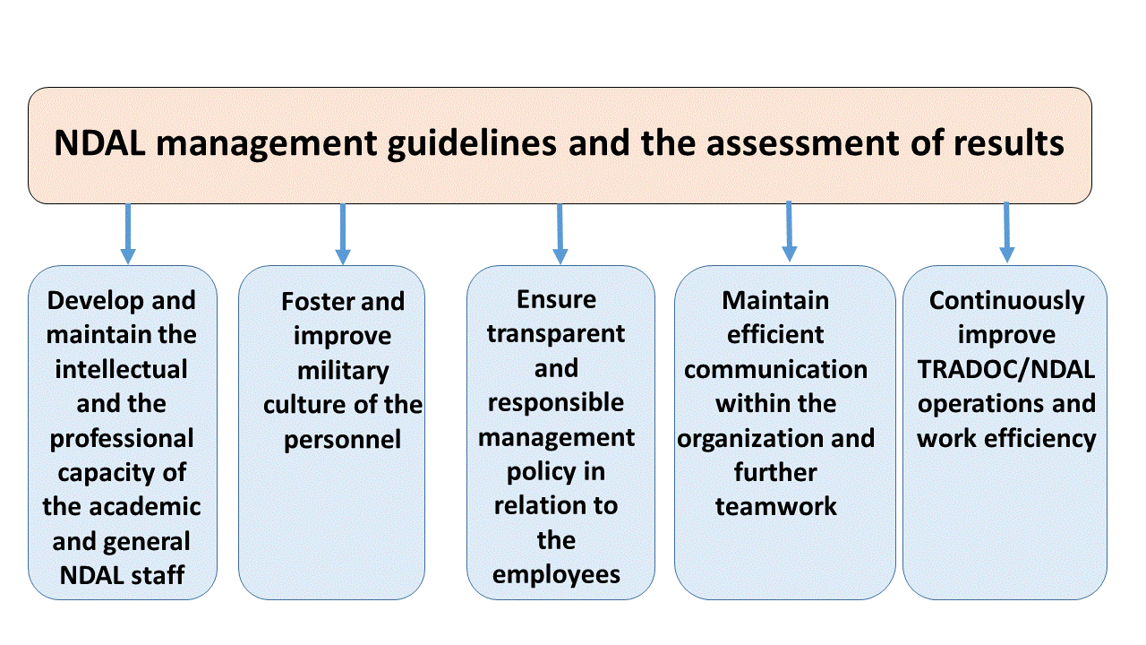

- Analysis of the implementation of the NDAL development strategy (SWOT)

Strengths | Weaknesses
1. The lecturers of the military orientation courses have many years of practical experience in the National Armed Forces, including participation in international operations and NATO headquarters.  2. Academic courses are delivered by highly qualified lecturers.  3. The NDAL has a permanent staff of civilian/academic staff who carry out scientific research and study work.  4. Students have the opportunity to participate in research projects in military science.  5. The NDAL has sufficient methodological support for study programmes.  6. The NDAL regularly develops study programmes in line with NATO and NAF developments.  7. Regular business contacts with employers and with employers' involvement in the implementation of the study process.  8. International academic and military cooperation.  9. Cadets are soldiers in the professional service and receive social guarantees established by the laws and regulations.  10. Cadets are provided with a place in the service upon graduation from the NDAL.  11. Students have the opportunity to improve their general level of physical fitness. | 1. Insufficient provision of modern weapons, equipment and other technical means for the training process; this should be requested from the NAF units.  2. Difficulties in involving military specialists in certain military courses of study due to their workload in the primary service.  3. The NAF has a limited number of qualified specialists with the appropriate academic background for teaching in the NDAL.  4. The NDAL infrastructure will need improvements as student numbers increase.  5. It is difficult to reconcile the educational needs of NAF soldiers with the requirements of the Ministry of Education and Science.  6. Insufficient resources to train NF and AF officers without the support of collaborating universities.  7. Insufficient resources for the NDAL to implement the professional Master's programme independently of BALTDEFCOL.
Opportunities | Threats
1. Involve guest lecturers from foreign military universities in the implementation of certain study courses.  2. Participate in student exchange programmes with military universities in other countries.  3. The defense sector is one of the priority sectors of public administration.  4. Increasing cooperation with other universities, public institutions. | 1. The demographic situation of the country makes the recruitment process for NDAL studies difficult.  2. In the event of a real threat to the country, studies will be interrupted and students will perform military duties.  3. Resource scarcity.  4. Competitiveness with other universities.  5. Public mistrust of the importance of the military profession.

- Approval, review and implementation of the NDAL development strategy
The NDAL Development Strategy is examined by the Academy's Senate. The decision of the Senate shall take effect upon the order of the Rector. The Development Strategy is approved by the Constitutional Assembly of the NDAL. The NDAL Council, established under the authority of the Ministry of Defence, will take over the functions of the Constituent Assembly and will be responsible for the strategic development of the NDAL, as well as approving the NDAL Development Strategy. The NDAL Development Strategy will be implemented within the NDAL allocated national budget.
According to the National Security Law, a new National Defence Concept (NDC) is developed and approved every four years and, therefore, the NDAL Development Strategy will be updated in line with the requirements of the new NDC.
If, during the implementation of the NDAL Development Strategy, changes are made to external regulatory legislation relevant to national defence, the necessary changes will be made to the NDAL Development Strategy.
The implementation of the NDAL Development Strategy may be affected by amendments in the internal normative and regulatory enactments of the MoD and the NAF, which are relevant to the implementation of the NDAL Development Strategy goals and objectives.
The NDAL internal laws and regulations will be developed and updated in line with the goals and objectives set out in the NDAL Development Strategy.

NATO (2022). NATO 2022 Strategic Concept. Brussels: NATO.
NATO (2021). Warfare Capstone Concept (NWCC). Brussels: NATO.

