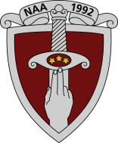 | NATIONAL DEFENCE ACADEMY OF LATVIA  Short-cycle Professional Higher Education Programme  Practical Military Management
APPLICATION FORM*
NAME:
SURNAME:
PERSONAL CODE:
DECLARED PLACE OF RESIDENCE:
ACTUAL RESIDENCE:
E-MAIL:
PHONE NUMBER:
EDUCATION: _______________, ________________________________.
(secondary, higher) (title of the educational institution)

*Filled-in form must be signed by the electronic signature and sent to the study programme director lita.avotina@mil.lv

Signature

Confirmed by NDAL 09.06.2025.Academic Council meeting minutes No.46 Decision No.1

