APPROVED BY
the National Defense Academy of Latvia Senate Meeting on 29 November, 2022, Minutes No. Nr.6/2022 , Decision No.3

IN FORCE WITH
Rector of
the National Defense Academy of Latvia
Oder No. 195, 2 December, 2022

National Defense Academy of Latvia

QUALITY POLICY

2022

Contents

- Rationale for the quality policy
- Principles of quality and excellence
- Standards of the quality policy
- Quality assurance system model
- Areas of quality assurance
- Principles of the study quality assurance
- Internal procedures for maintaining the quality of studies/learning
- Student-centered approach and assessment of achievement
- Maintenance of the teaching staff qualification
- Teaching resources and student support
- Risk management methodology

1. Rationale for the quality policy

The Quality Policy of the National Defense Academy of Latvia (hereinafter - the Quality Policy) has been developed in accordance with the Standards and Guidelines for Quality Assurance in the European Higher Education Area (ESG), approved at the European Education Ministers' Summit in Yerevan on 15-16 May 2015, and in compliance with the laws and regulations of the Republic of Latvia: Law on Higher Education, Law on Education, Cabinet of Ministers Regulations of 26 August 2014 No. 512 "Regulations on the State Standard of Second Level Professional Higher Education", Cabinet of Ministers Regulations of 11 December 2018 No.794 "Regulations on Accreditation of Higher Education Institutions and Colleges", Cabinet of Ministers Regulations of 16 December 2014 No.774 "Regulations on the Operation of the National Defense Academy of Latvia", Cabinet of Ministers Regulations of 11 December 2018 No.795 "Study Programme Licensing Regulations", Cabinet of Ministers Regulations of 11 December 2018 No.793 "Regulations on Opening and Accreditation of Study Directions", the guidelines established by the Ministry of Defense (hereinafter - MOD) - "Personnel Policy of the Ministry of Defense, its Subordinate Institutions, including the National Armed Forces", approved by Order No.185 of the Minister of Defense of 6 November 2012 "On Approval of the Personnel Policy of the Ministry of Defense, its Subordinate Institutions, including the National Armed Forces", the National Armed Forces (LNAF) Development Plan 2016-2028, the tasks set by the LNAF Commander, as well as in accordance with the NAF Development Strategy 2022-2028 and in compliance with the internal normative acts of the NAF.
The Quality Policy is aimed at the implementation of the mission of the NDAL, the achievement of strategic goals and sustainable development in the field of higher professional military education in the Latvian and European education space.
The Quality Policy defines the procedures for the management and development of the external and internal quality assurance system of the NDAL.

The aim of the Quality Policy is to implement a comprehensive quality assurance system at the NDAL for the implementation of the accredited study programmes of the study field "Military Defense", as well as for the implementation of military-vocational career and qualification courses and lifelong learning, which is to be followed by the NDAL management team, academic staff and professional army soldiers who are responsible for the implementation of the NDAL study programmes of professional higher education and military training.

The following terms are used in the Quality Policy:

External quality - the state of the accredited study programmes/military training system, which reflects the compliance of the NDAL cadets and students' training activities with the educational objectives of the Ministry of Education and Science and the MoD and the NDAL development strategy, as well as the requirements of the direct employers -units of Regular Forces of the NAF;
Internal quality - NDAL guidelines and standards for monitoring the outcomes of interaction between the staff, students/learners and the learning environment;
Quality of education - the educational process, content, environment and governance that ensure inclusive education and the opportunity to achieve high quality results in line with the set goals;
Quality - a characteristic, attribute or set of characteristics that characterize the conformity of an object, process to a predefined set of requirements;
Quality indicators - sources of information (statistical units, reports, expert reports, management and trainee evaluations, legislation and other sources) describing the level of achievement of the NDAL study/learning quality and requirements;
Quality assurance system - the organizational structure, procedures, processes and resources to ensure quality;
NDAL students - soldiers/ cadets studying in accredited study programmes, professional service soldiers and the soldiers of the National Guard studying career, qualification development or lifelong learning courses;
Self-assessment report - the main source of quantitative and qualitative information on the development of the NDAL, used as a basis for external evaluation;
Self-assessment is a systematic and comprehensive assessment of performance and results against the set criteria.

2. Principles of quality and excellence

The NDAL Quality Policy provides for an approach of excellence in the establishment, maintenance, evaluation and improvement of the quality assurance system. The Quality Policy and the Core Principles of Excellence are binding for every NDAL employee. The NDAL concept of excellence is based on the premise that for the achievement of excellent results, the following principles must be implemented:
Strategic and systemic approach - the quality policy is based on the NDAL Development Strategy and covers all processes of the NDAL organization;
Goal-oriented and result-oriented approach - achieving optimal results for excellence by all entities involved in the NDAL activities;
Customer focus - excellence in the NDAL means maintaining an independent military culture and creating value for its customers (students, audience, graduates, and employers);
Co-responsibility - involvement of all levels (management, academic staff, civilian staff and military personnel) in maintaining and improving the quality assurance system);
Leadership - focused and inspired military leaders with a clear vision for the future and a fact-based approach to decision-making;
Communication - purposeful, business-like internal communication of the NDAL at all management levels and effective external communication with the MoD, NAF Joint Headquarters (hereinafter - JH), NAF Regular Force Units (hereinafter - RFU), Ministry of Education and Science (hereinafter - MES), universities, institutions and the public;
Cooperation and social responsibility - building and maintaining partnerships between Latvian higher education and the European/NATO military professional education space. NDAL, as a unit of the NAF, in the eyes of the public, is responsible for training highly qualified professional service soldiers for the National defense
Continuous improvement - continuous learning and upskilling, systematic evaluation of results, introducing changes to improve quality and seeking new opportunities for improvement.

3. Standards of the quality policy

The Quality Policy defines the governance model for external quality assurance and the internal quality assurance system of the NDAL:

- The maintenance of the external quality policy of the NDAL is carried out in cooperation with the MoD, the Ministry of Education, the National Armed Forces, Latvian higher education institutions, as well as foreign armed forces and military education institutions, where the main quality criteria are:
  - Compliance of the higher professional military education with European and Latvian higher education and professional standards;
  - Ensuring accreditation of study programmes in the study field "Military Defense";
  - Requirements for the balance of academic education standards in relation to the professional competences of soldiers;
  - Systematic feedback from employers - evaluation by the NAF RFU and the National Guard of the Republic of Latvia (hereinafter - NG) regarding the education and professional qualifications acquired by the NDAL graduates and their relevance to military service;
  - NDAL graduates' satisfaction with their studies at the NDAL, as well as their assessment of the qualifications they have acquired to perform their service duties in the NAF;
  - Development of interdisciplinary applied fields of military science, as well as public information on the results of scientific research on national security and defense issues;
  - Visibility and competitiveness of the NDAL in the Latvian professional higher education space.

- Key factors for the NDAL internal quality assurance policy:

  - Military leadership processes - mission, goals, objectives, planning, timely decision-making, internal communication and inter-departmental cooperation;
  - Activities and responsibilities of the NDAL collegiate decision-making bodies - NDAL Council, Senate, Council of Studies, Scientific Council, Academic Arbitration Court, Council of Elders (Student Council);
  - Quality of academic staff - qualifications, research, professional competence, professional development;
  - Compliance of the content of study programmes of the study field "Military Defense" with the standards of professional higher education and the competences of professional service;
  - Internal quality assurance system procedures ensure interaction between military leadership and quality control of studies;
  - Improvement the NDAL infrastructure and study resources;
  - Provision of students with modern theoretical and practical teaching methods;
  - Implementation of a digitized learning environment on ILIAS platform and LAIS platform for integrated student record keeping;
  - Maintenance of military culture, leadership and the quality of studies at the NDAL in comparison to Latvia's higher education space contributes to the recruitment of candidates for professional service, selection of future soldiers and opportunities for young people to study at the NDAL to become officers and defenders of their country.

- Quality assurance system model

The planning, management and quality assurance system of the NDAL are based on the hierarchy of the organization and on external and internal normative acts governing the NDAL as an applied university and as a unit of the NAF. A quality assurance system consists of interrelated phases - quality planning, quality assurance, quality control and continuous improvement.

- The basis for the planning of the activities of the NDAL is the NAF Development Plan and the NDAL Development Strategy, which define the strategic development priorities, goals and objectives of the applied higher education institution.
- The administration of the NDAL defines overarching processes that include the organizational structure and resources required, inter-departmental cooperation, the delivery of tasks and the timelines to achieve the defined objectives.
- The academic and scientific performance management system is based on the Law on Higher Education Institutions and the Law on Scientific Activity, where performance is organized according to the NDAL management processes, rights and obligations of the persons responsible for the deliverables.

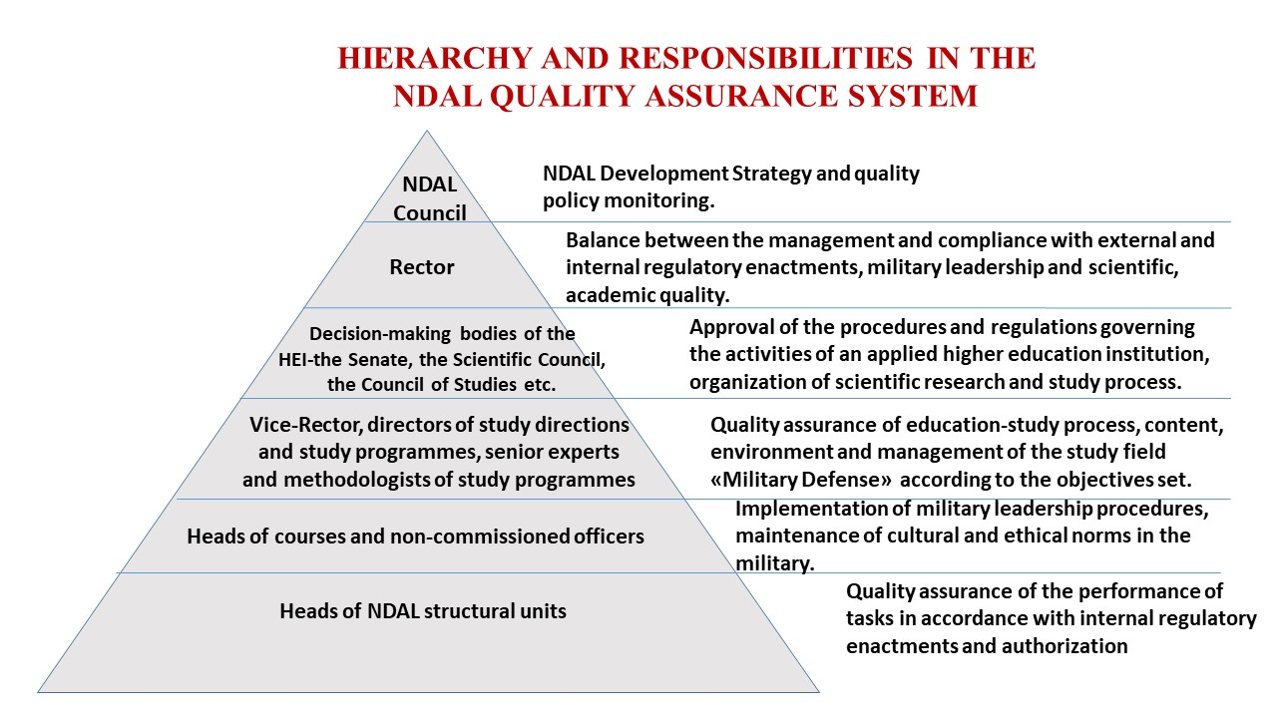

- Areas of quality assurance

There are three main directions (quality assurance areas) in the process management of the quality assurance system, the effectiveness of which is measured in the internal normative acts of the MoD, NAF and NDAL.

- Management process areas:
  - Development, updating and monitoring of the strategy
  - Decision-making, implementation and follow-up
  - Improvement of governance and risk management
  - Cyclical external quality assurance
  - Internal quality control

- Educational process areas:
  - Planning and implementing of the study process
  - Scientific research
  - Distance learning
  - Provision of career courses and maintenance of lifelong learning
  - Ensuring international cooperation
  - Attraction and enrollment of international students and the provision of studies

- Support processes:
  - Human resources management and development
  - Financial resource management
  - Infrastructure provision and maintenance
  - Provision of external and internal business communication
  - Maintenance of the NDAL library
  - Provision of the procurement process

- Principles of quality assurance

The basic principles of the quality of studies at the NDAL are based on the requirements of the Regulations on the State standard for the professional higher education and the NAF guidelines on ensuring competences of professional service soldiers in order to achieve high quality results in accordance with the goals set by the society and the state in the field of higher education and military defense.
The priority areas for NDAL quality assessment are as follows:
- Relevance to the objectives
- Quality study/learning
- Integrative environment
- Efficient management

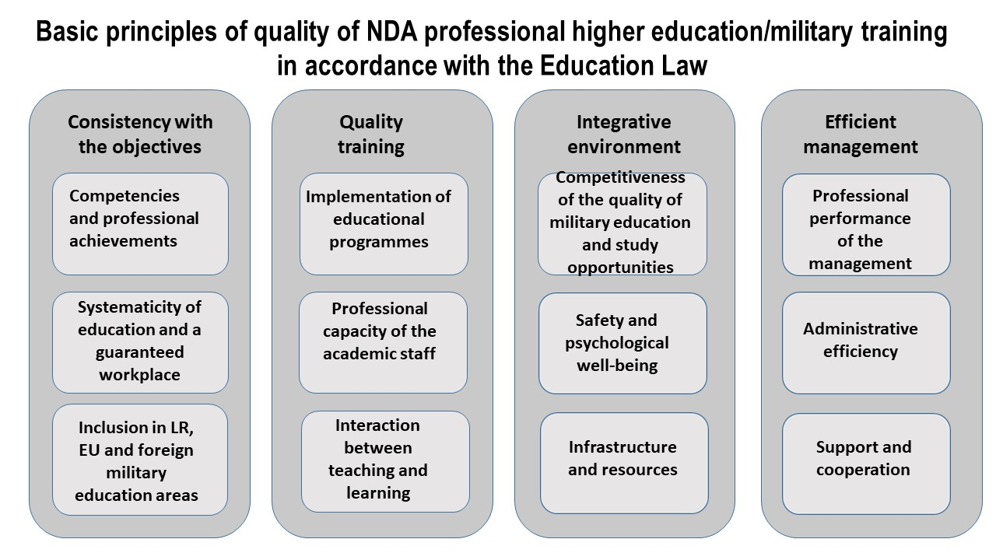

- Internal procedures for maintaining the quality of studies/learning

The maintenance of the internal study/learning quality at the NDAL is the application of continuous management procedures at the NDAL, which include a sequence of action steps:

- Information extraction and data processing
- Analysis of results
- Identifying problems and preparing proposals
- Setting targets and taking immediate action
- Developing a quality improvement plan
- Implementation and monitoring of the action plan
- Analyzing and improving results

Quality assurance procedures for the implementation of study programmes and career/qualification courses, military training courses or lifelong learning programmes accredited by the NDAL in the field of study "Military Defense" are carried out systematically in accordance with the strategic objectives of the NDAL management and internal normative acts.
- The responsibility for ensuring the quality of studies/learning lies with the staff of the NDAL management team, the decision-making bodies of the university, study programme directors, heads of departments, course supervisors and the academic staff.
- The internal quality assessment of study/learning is based on the quality reports of the programme management and feedback from students using quantitative and qualitative research methods.

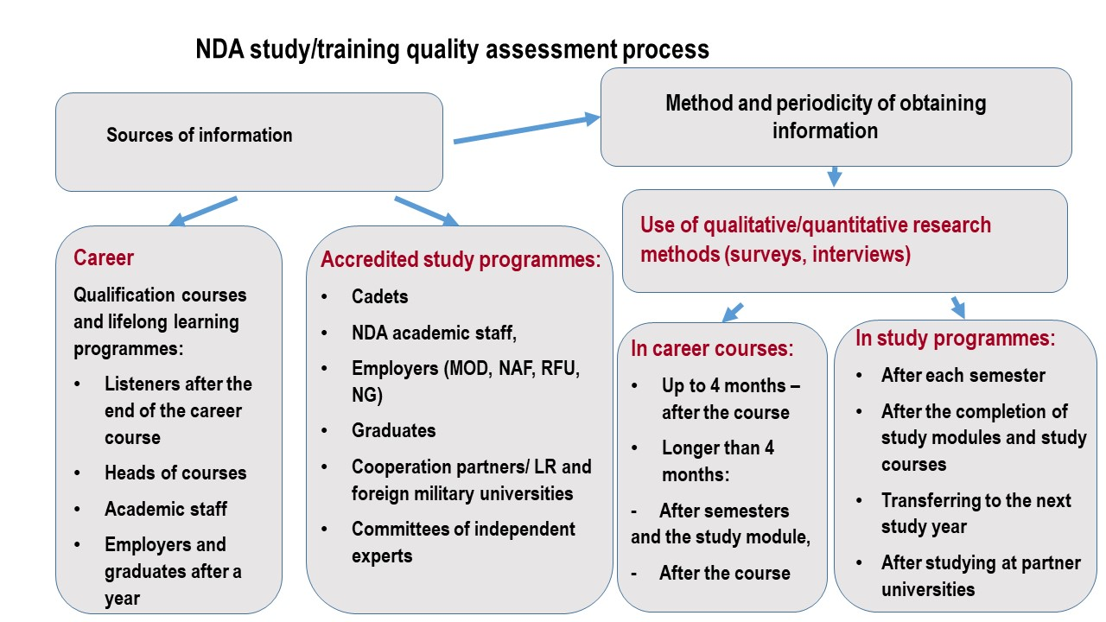

- The analysis of the results of the study/learning quality assessment and the preparation of the report shall be carried out by the directors of the NDAL Military Leadership Land Forces Studies Course, Air Forces Studies Course, Naval Studies Course, Command Staff Officer and Military Defense Studies programmes elected by the Senate in cooperation with the Senior Study Development Expert of the Office for Study Planning and Support and responsible study programme methodologists.
- The Vice-Rector of the NDAL is responsible for the overall quality reporting of the study field "Military Defense".
- The heads of the NDAL career/training courses submit the quality assessment reports to the NDAL Training Council or the Senate for a decision.

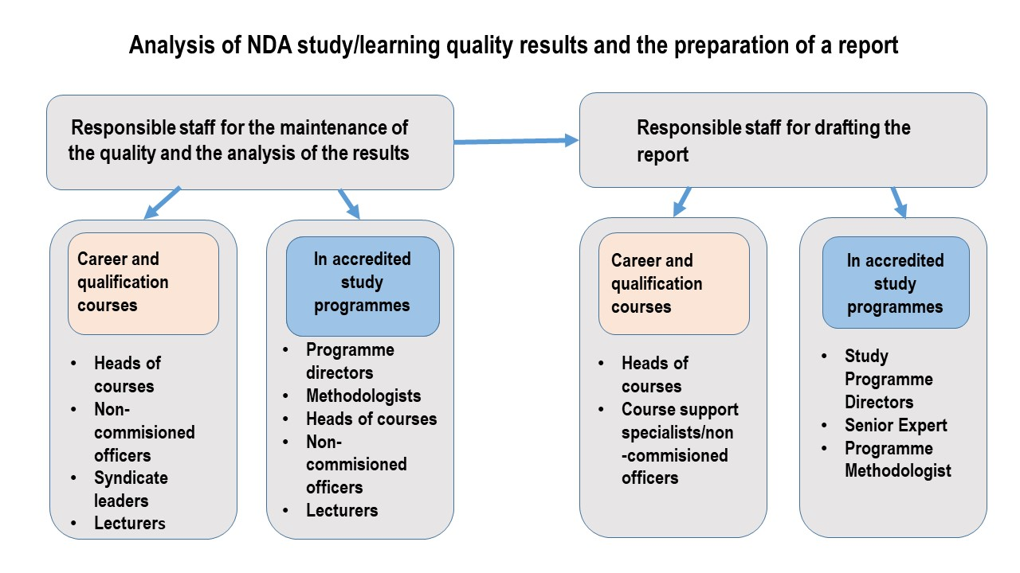

- Based on the comprehensive quality assessment reports, the management teams and heads of the responsible units of the NAF TRADOC/NDAL recommend improvement measures and develop action plans (tasks to be performed, responsible persons, timeframe and resources required) in line with the development priorities of the NAF, the NAF TRADOC and NDAL for continuous quality assurance of studies.

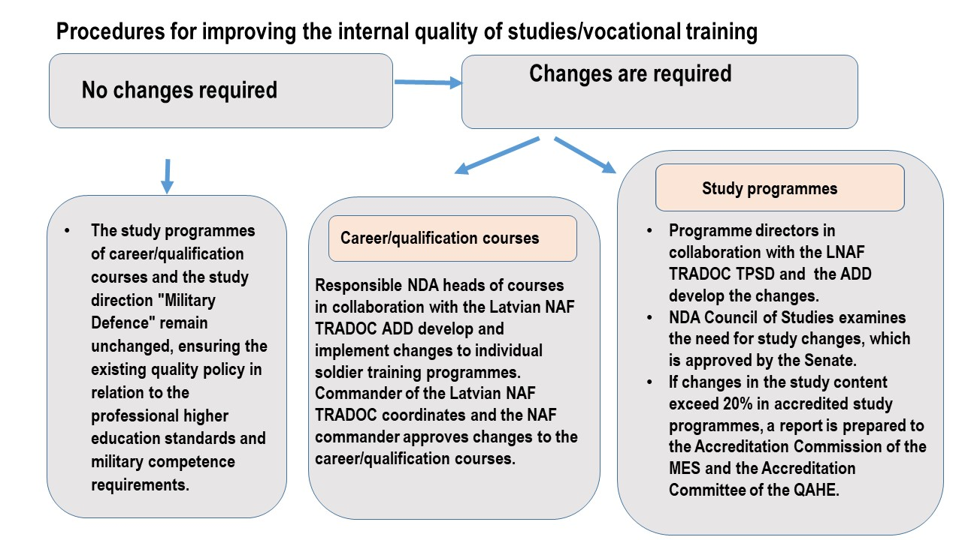

- Changes to accredited study programmes are reflected annually in the Study Programme Quality Report of the field of study, reviewed by the Council of Studies, and confirmed by the Senate meeting before the beginning of the current academic year.
- The Senior Expert for Study Development of the NDAL Training and Planning and Support Department prepares and periodically reviews the methods of study quality measurement and the content of surveys in cooperation with the heads of departments and academic staff.
- The NDAL Council of Studies approves the content of quality assessment surveys for accredited study programmes, career courses, military training and lifelong learning in the study direction "Military Defense" in order to measure comprehensively the internal quality of studies.

- Student-centered approach and assessment of the achievement

In accordance with the quality assurance standards and guidelines of the European Higher Education Area, NDAL, as a university of applied higher education and the only higher military education institution in Latvia, focuses on a student-centered approach and the assessment of students' individual achievements in order to meet the national and the NAF objectives in the professional training of future officers and the maintenance of academic knowledge in the study direction "Military Defense", where the main quality criteria of the NDAL are as follows:

- Direct student selection procedures;
- Professional work by the staff of the NAF TRADOC/NDAL to prepare cadet candidates for studies at the NDAL during their basic military training;
- Clarity of the objectives of the NDAL in relation to cadet military leadership and study organization;
- Adherence to military culture and ethics;
- Acquisition of academic knowledge and military-professional competences;
- Availability of commanding officers, instructors and academic staff;
- Individual approach to improve the overall physical and physiological fitness of cadets for professional service;
- Professional academic staff, who use modern, interactive study methods to stimulate students' intellectual potential;
- Study infrastructure and resource provision;
- Involving students in the NDAL quality assurance feedback system;
- Ensuring the functioning of the students' decision-making body - the Council of Elders;
- Provision of students with professional international experience in foreign AF and military universities;
- Officer development and career opportunities in the NAF;
- Competitiveness of the educational competences of the graduates of the NDAL professional higher studies programmes in Military Leadership in the Latvian labor market.

The quality policy emphasizes the high demands for the professional service soldiers, as well as critically assesses the risk factors related to the demographic situation in Latvia and the military education practices of foreign armed forces in relation to generational change and the acquisition of new competences not only in the military-professional field, but in the general higher education space in Latvia and Europe, where a student-centered individual approach is the determining factor.
The assessment of the achievements of NDAL students is based not only on the system of educational grades, but also on the opinions of the NDAL Military Leadership Team soldiers and academic staff on the individual progress of each student in both military leadership and academic competences.

- Maintaining the qualifications of teaching staff

In implementing the quality policy, the NDAL is aware of the important role of the teaching staff in maintaining the competence of the teaching staff and thus contributing to the acquisition of knowledge, competences and skills by the students. The student-centered approach requires that the NDAL maintains a highly qualified independent academic staff (civilian employees and soldiers) in its personnel policy, and also attracts academic staff from other universities and soldiers from the NAF units to the study process. The NDAL ensures the quality of academic staff and a supportive environment that enables staff to carry out their work effectively and to the following standards:

- The NDAL internal regulations establish clear and fair procedures for the recruitment of the academic staff, the calculation of workloads and annual performance appraisals;
- Standardized job descriptions, taking into account the professional qualifications required for the position and the specificities of the military working environment;
- Continuous improvement of the staff performance and employee appraisal process;
- Staff are given opportunities to improve their skills and professionalism;
- Fostering cooperation between academic staff in the Latvian education sector, as well as international cooperation, especially in the field of military defense;
- At least once a year, each lecturer is given the opportunity to update and broaden his/her knowledge and professionalism by acquiring foreign experience, participating in international conferences or internships at foreign universities or in courses, seminars, training, etc. organized in collaboration with NATO countries' armed forces, as well as within the Erasmus mobility programmes;
- Scientific activities in interdisciplinary fields of military science are promoted, thus strengthening the link between higher professional military education and science;
- Promoting the use of innovative teaching methods and new technologies;
- Promoting a safe, healthy and psychologically supportive work environment;
- Information systems are used to manage and administer staff more effectively.

10. Teaching resources and student support

The organization shall define and provide the resources necessary for the establishment, implementation, maintenance and continuous improvement of the quality assurance system. To ensure a successful applied higher education environment, the NDAL provides a wide range of resources for students: library, welfare center, cadet club, canteen, dormitory, facilities and IT infrastructure necessary for studies, as well as human resources (teaching staff, course supervisors and sergeants, and other study advisors).
Each year, financial resources are allocated to the Council of Elders to improve the learning environment as deemed necessary by the students.
For the purpose of international cooperation experience and mobility of students, student ratings are taken into account in accordance with the internal regulations of the NDAL on the evaluation criteria for soldiers and NDAL students.
Students are soldiers in the professional service who receive the social guarantees provided for in the laws and regulations.
Students are provided with full opportunities to play sport and improve their general physical fitness, as well as opportunities to participate in applied military sports.
Students are provided with equipment for training in military study blocks.
The support and administrative staff of the Training Planning and Support Department of the NDAL play a key role in the provision of support services and must therefore be qualified and given an opportunity to develop their competences.
In order to maintain a military culture and a positive psychological environment, students have access to the support of the NAF psychologists and the NAF chaplain services.

- Risk management methodology

NDAL risk management objective is focused on the implementation and development of its vision, mission and development strategy at all levels of management, where:

- Risk management is an ongoing structured and coordinated process across all NDAL entities to identify, prevent and report on potential threats that may affect the NDAL operations and the achievement of its objectives;
- Risk management identifies, analyses and controls those risks that are relevant to the achievement of the objectives, and reduces uncertainty and uninformed decision-making in the pursuit of the objectives of the NDAL as an applied university and a unit of the NAF;
- Risk management reduces inefficient use of financial and other resources, minimizes future losses in the event of adverse events, and highlights opportunities for improvement and development of the NDAL;
- Identified risks reduce the severity of the consequences, include alternatives for prevention and an action plan.

